Unit 4 Chemistry Test: Proteins and plants
Name: ________________________ Mark: __/50
Section A: Multiple Choice
Question 1
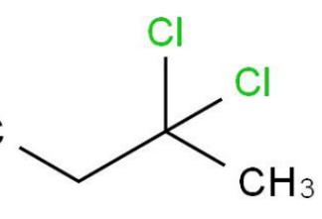
Which of the following molecules contains a chiral carbon?
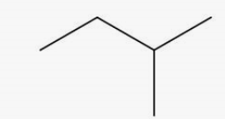
A. B.

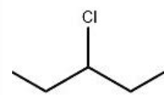
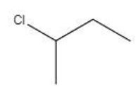
C. D.

Use the following information to answer Questions 2 and 3
Lysine is a 2-amino acid.

Question 2
When lysine is part of the tertiary structure of a protein, it

A. is part of dispersion forces only.
B. forms hydrogen bonds or covalent bonds with other amino acids.
C. forms ionic bonds only with other amino acids.
D. can form ionic bonds or hydrogen bonds with other amino acids.

Question 3
At pH 2, lysine will form

A. a zwitterion.
B. a cation with a charge of +2.
C. a cation with a charge of +1.
D. an anion with a charge of -1.

Question 4
When oil is extracted from sunflower seeds, the sunflower seeds are soaked in hexane after their initial pressing. The reason for this step is that

A. the hexane acts as a catalyst to convert the remaining oil to biodiesel.
B. the non-polar hexane will extract remaining oil from the plant.
C. the hexane will remove any water remaining in the seeds for recycling.
D. the hexane will remove polar impurities from the remaining plant material.

Question 5
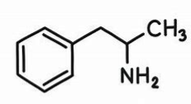
A medicine extracted from the bark of the willow tree is found to produce a sharp absorption at 1700 cm⁻¹ and a broad absorption at 3300 cm⁻¹. It produces other significant absorptions as well. The active ingredient could be
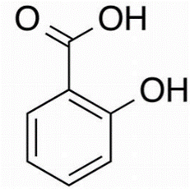
A. B.

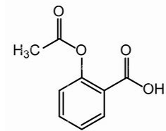
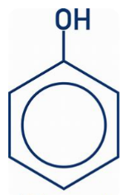
C. D.

Question 6
When milk is heated in a saucepan, a skin starts to form on the surface when the milk is over 60 ⁰C. The formation of the skin

A. is due to hydrolysis of the biomolecules in the milk.
B. is due to the denaturation of proteins in the milk.
C. is due to the changes in pH of the milk due to the heat.
D. is due to the disruption of the primary structure of molecules in milk.

Question 7
Select the correct statement about the optimum pH that an enzyme operates at.

A. The optimum pH for all enzymes is 7.
B. All enzymes have the same optimum pH but it is slightly less than 7.
C. All enzymes have the same optimum pH of around 8.
D. The optimum pH of enzymes varies significantly.

Question 8
Solvent extraction on the Australian native plant, eremophila freelingii, extracts up to forty possible active ingredients. If a researcher wants to study each of these components, the most likely step to be taken with the extract is to

A. use fractional distillation to separate these forty components.
B. use steam distillation to extract any remaining components.
C. use a form of chromatography to separate the extract into its individual components.
D. run NMR spectra of the extract to identify the components.

Use the following information to answer Questions 9 and 10
Catalase is an enzyme that increases the rate of decomposition of hydrogen peroxide, H₂O₂. A researcher conducts an experiment to measure the effect of temperature on the time taken for 10 mL of oxygen to be evolved from a 50 mL sample of H₂O₂ after catalase is added.

Trial 1 is conducted at 10 ⁰C, and the temperature is increased by 10 ⁰C in all five subsequent trials.

Question 9
A graph of the times recorded for trials 1 to 6 is likely to show that

A. early trials show a trend to a shorter time but the latter trials show the time required increasing.
B. early trials show the time required increasing but the latter trials show this time decreasing.
C. the time required increases steadily as the rate is increasing with temperature.
D. the time required drops consistently as the rate of reaction increases with temperature.

Question 10
Select the correct alternative relating to the action of catalase.

A. Catalase has the appropriate shape to fit perfectly into the active site of H₂O₂.
B. After each H₂O₂ breaks down the active site becomes available to act on another molecule.
C. Each active site can only catalyse one decomposition reaction.
D. The effectiveness of catalase is not dependent on temperature..

Section B: Short answer
Question 1 (10 marks)
a. i. Using the same drawing style as the data book, draw the zwitterion of proline. 1 mark

ii. Draw this amino acid as it appears in pH 12 solution. 1 mark

b. i. Draw one of the dipeptides that forms when serine reacts with leucine. 2 marks

ii. Why does the previous part of this question say ‘one of the dipeptides’ when only two
molecules are bonding? 1 mark

________________________________________________________________________

iii. Refer to the dipeptide you drew to explain the cause of secondary bonding in protein
molecules. 2 marks

________________________________________________________________________

________________________________________________________________________

________________________________________________________________________

c. A segment of a protein molecule is drawn below. Two fo the R groups on the amino acids have
been circled.
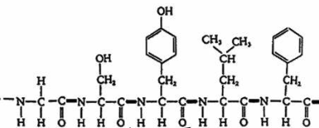

i. Explain the likely types of bonding that each of the circled R groups will form. 2 marks

First R group: ___________________________________________________

Second R group: ___________________________________________________
ii. Name an amino has that has an R group that can form covalent bonds. __________ 1 mark

Question 2 (8 marks)
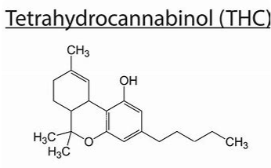
The molecule shown below is tetrahydrocannabinol (THC), one of the active ingredients in the now legalised marijuana. This molecule is the subject of significant research as to whether the plant’s medicinal properties are due to this molecule only, or to one of the lesser-known substances, in the plant leaves.

a. i. Discuss the choice of a solvent that is likely to successfully extract THC from plant leaves.
3 marks
_________________________________________________________________________

_________________________________________________________________________

_________________________________________________________________________

ii. How does the relatively solubility of this molecule also influence the way in which THC is
separated from other substances in the plant extract? 2 marks

_________________________________________________________________________

_________________________________________________________________________

_________________________________________________________________________

b. i. The melting point of THC is 66 ºC. Explain how the melting point can be used to confirm that
a sample might actually be THC. 2 marks

_________________________________________________________________________

_________________________________________________________________________

_________________________________________________________________________

ii. State one likely absorption of THC when tested in an infrared spectrometer. 1 mark

________________________________________________________________________
Question 3 (12 marks)
The diagram below shows two forms of the drug naproxen.
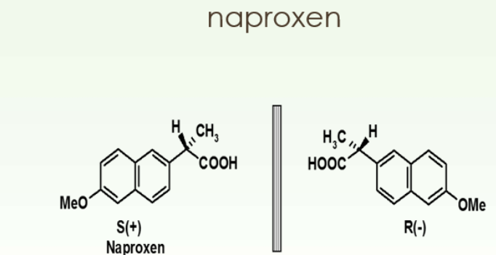

a. i. Explain the difference between the two molecules shown. Your answer should refer to any
carbon atom of extra significance. 3 marks

_________________________________________________________________________

________________________________________________________________________

________________________________________________________________________

________________________________________________________________________

ii. How will the viscosity of these two molecules compare? Justify your answer. 2 marks

_________________________________________________________________________

________________________________________________________________________

iii. Butanol has two structural isomers. Draw these isomers and explain why they are different
from the naproxen examples above. 2 marks

_________________________________________________________________________

________________________________________________________________________

b. i. S-naproxen is used to treat arthritis but R-naproxen causes liver poisoning. Discuss why
molecules with the same structure can impact differently in the body. 2 marks

_________________________________________________________________________

________________________________________________________________________

ii. How could you test a sample of naproxen to determine which enantiomer it is? 1 mark

_________________________________________________________________________

________________________________________________________________________

c. Naproxen’s action is typical of a competitive enzyme inhibitor. Explain how naproxen acts.
2 marks

_________________________________________________________________________

________________________________________________________________________

Question 4 (10 marks)

a. The graph below shows the performance of three different enzymes at a range of pH values.
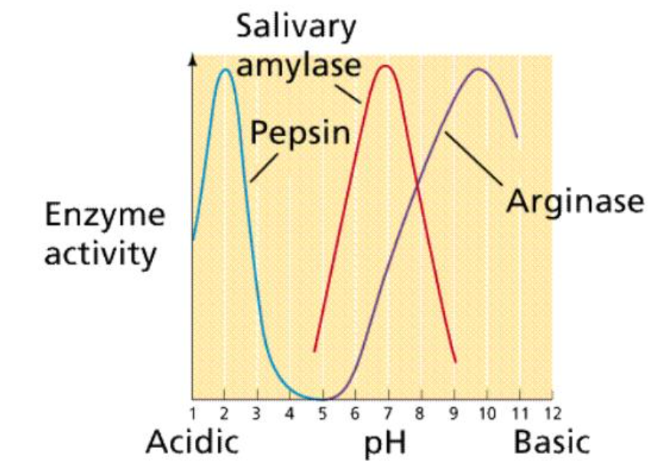
i. Identify two conclusions about enzymes and pH that you can draw from this graph. 2 marks

_________________________________________________________________________

________________________________________________________________________

ii. Suggest a structural reason why two enzymes might operate differently at the same pH.
1 mark
_________________________________________________________________________

________________________________________________________________________

b. The graph below shows the action of enzymes at different temperatures.
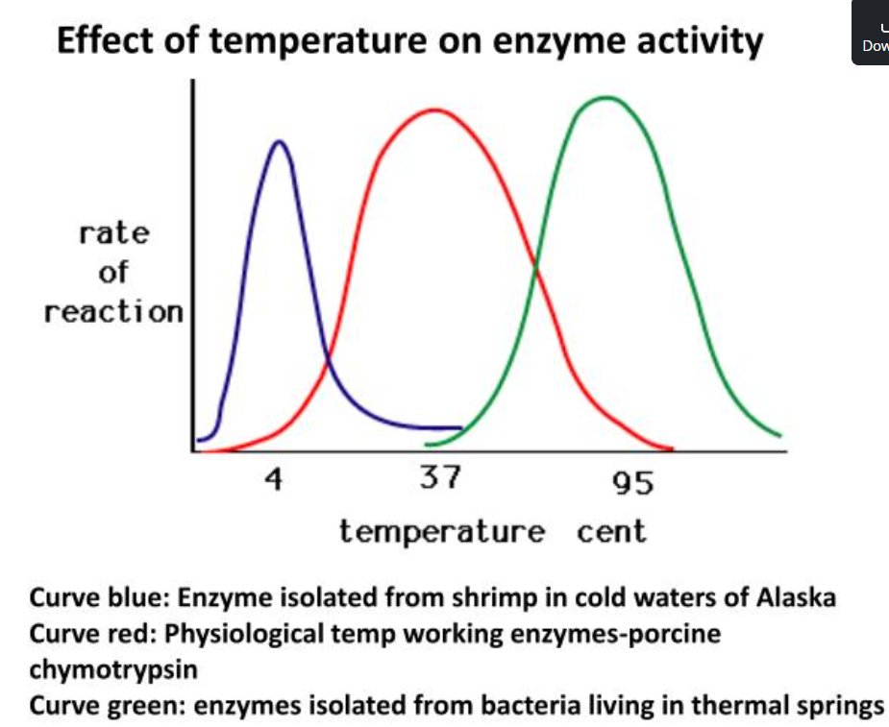
i. Explain the characteristic shape of each enzyme. Your answer should include an
explanation of a significant difference in the way inorganic catalysts operate compared to
enzymes. 4 marks

_________________________________________________________________________

________________________________________________________________________

_________________________________________________________________________

________________________________________________________________________

ii. Suggest a reason for nature having a different optimum temperature of each enzyme. 1 mark

__________________________________________________________________________

c. Knowing how effective enzymes are, scientists have been tempted to see if using high enzyme
concentration can lead to super fast reactions. The graph below shows the typical results they
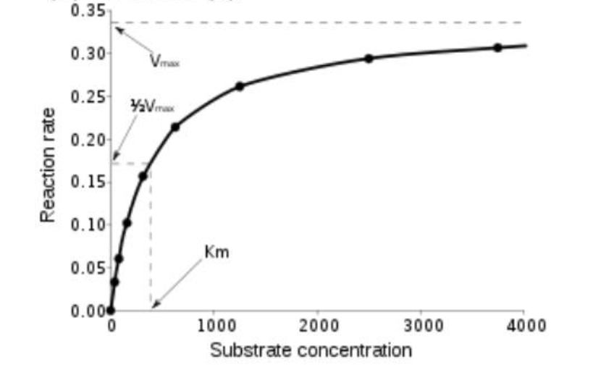
obtain. 2 marks

What conclusion can you draw from this graph? 2 marks
______________________________________________________________________

